Problem Statement 1:

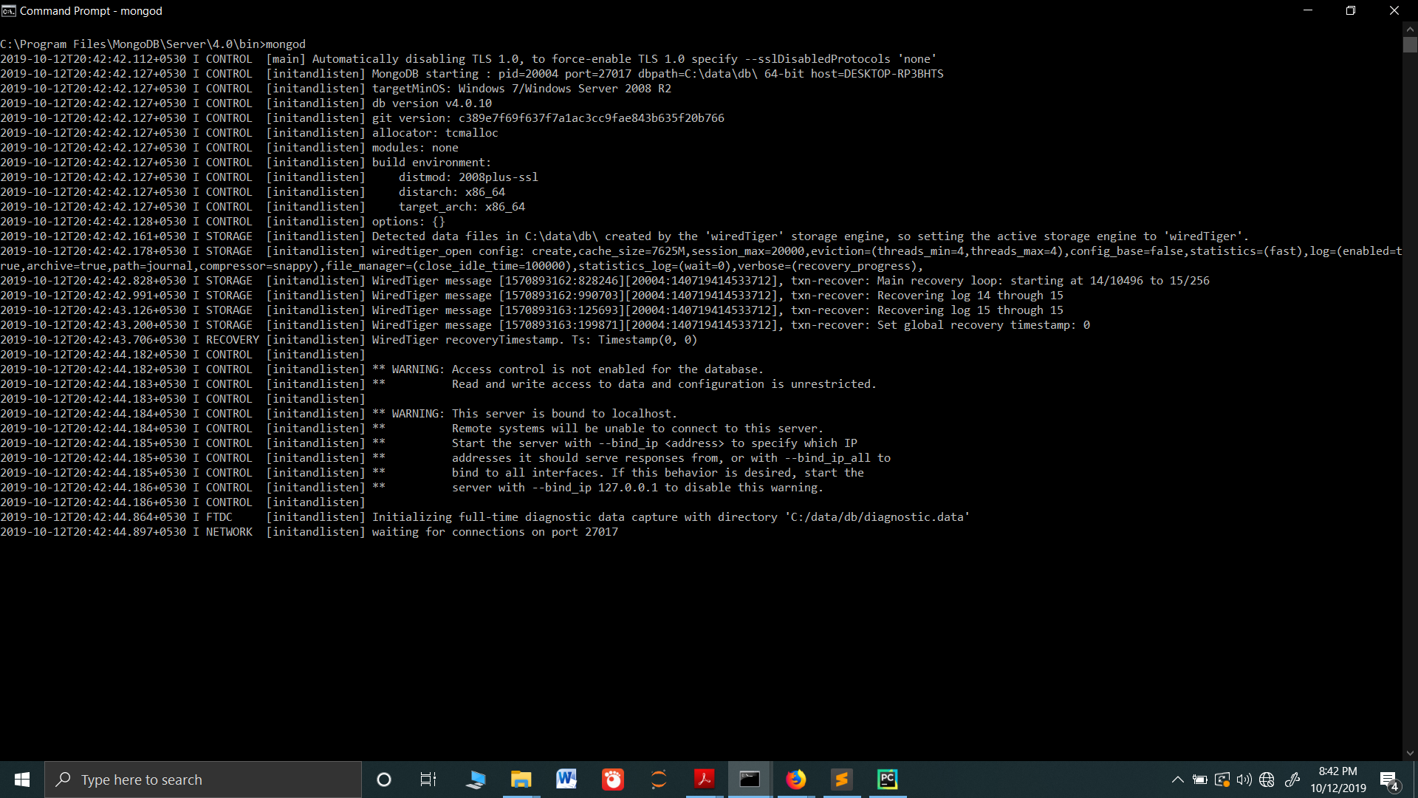

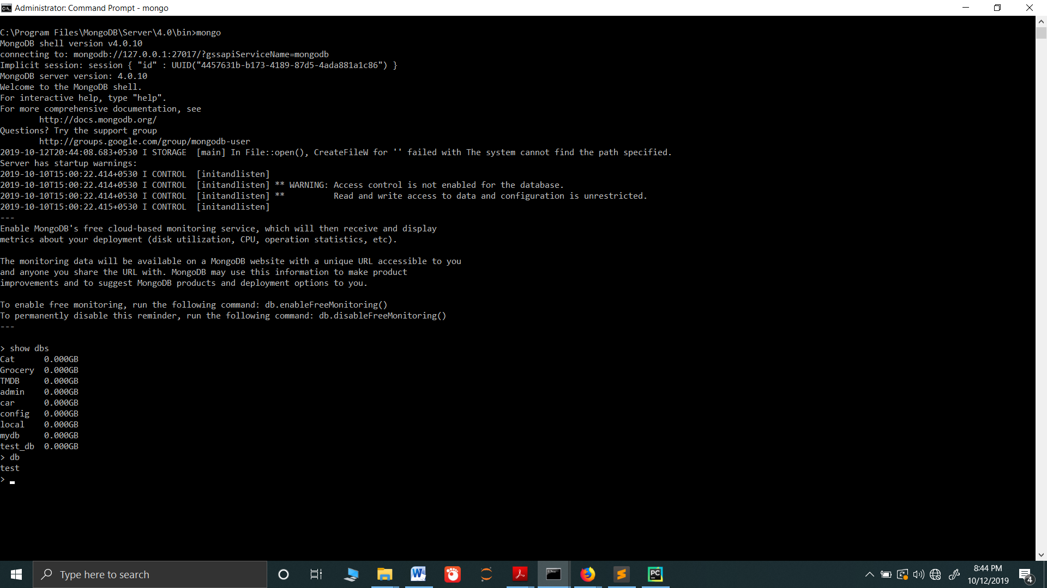

Problem Statement 2:

use Mongo_DB_Project

1: Customer Collection schema

db.createCollection("Customers", {  
 validator: {  
 $jsonSchema: {  
 bsonType: "object",  
 required: [ "customer_id","customer_name","contact_number", "address","birth_date" ],  
 properties: {  
  
 customer_id: {  
 bsonType: "string",  
 description: "must be a string and is required"  
 },  
 customer_name: {  
 bsonType: "string",  
 description: "must be a string and is required"  
 },  
 contact_number: {  
 bsonType: "int",  
 description: "must be a string and is required"  
 },  
 address: {  
 bsonType: "object",  
 required: [ "streetAddress","city","state","postalCode"],  
 properties: {  
 streetAddress: {  
 bsonType: "string",  
 description: "must be a string if the field exists"  
 },  
 city: {  
 bsonType: "string",  
 "description": "must be a string and is required"  
 },  
 state:{  
 bsonType: "string",  
 description: "must be a string if the field exists"  
 },  
 postalCode:{  
 bsonType: "int",  
 description: "must be a integier if the field exists"  
 }  
 }  
 },  
 birth_date:{  
 bsonType:"date",  
 "description": "must be a date and is required"  
 }  
 }  
 }  
 }  
})

2: Order collection schema

db.createCollection("Orders", {  
 validator: {  
 $jsonSchema: {  
 bsonType: "object",  
 required: [ "order_id","order_name","category", "brand","items","order_date","shipping_date"],  
 properties: {  
 order_id: {  
 bsonType: "string",  
 description: "must be a string and is required"  
 },  
 order_name: {  
 bsonType: "string",  
 description: "must be a string and is required"  
 },  
 category: {  
 bsonType: "object",  
 required: [ "category_id","category_name"],  
 properties: {  
 category_id: {  
 bsonType: "string",  
 description: "must be a string if the field exists"  
 },  
 category_name: {  
 bsonType: "string",  
 description: "must be a string if the field exists"  
 },  
 }  
 },  
 brand: {  
 bsonType: "object",  
 required: [ "brand_id","brand_name"],  
 properties: {  
 brand_id: {  
 bsonType: "string",  
 description: "must be a string if the field exists"  
 },  
 brand_name: {  
 bsonType: "string",  
 description: "must be a string if the field exists"  
 },  
 }  
 },  
 items: {  
 bsonType: "object",  
 required: [ "items_id","items_name","price"],  
 properties: {  
 items_id: {  
 bsonType: "string",  
 description: "must be a string if the field exists"  
 },  
 items_name: {  
 bsonType: "string",  
 description: "must be a string if the field exists"  
 },  
 price: {  
 bsonType: "int",  
 description: "must be a integer if the field exists"  
 }  
 }  
 },  
 order_date:{  
 bsonType: "date",  
 description: "must be a string if the field exists"  
 },  
 shipping_date:{  
 bsonType: "date",  
 description: "must be a string if the field exists"  
 },  
 }  
 }  
 }  
})

3: Categories collection schema

db.createCollection("Categories", {  
 validator: {  
 $jsonSchema: {  
 bsonType: "object",  
 required: [ "category_id","category_name","brands"],  
 properties: {  
 category_id: {  
 bsonType: "string",  
 description: "must be a string and is required"  
 },  
 category_name: {  
 bsonType: "string",  
 description: "must be a string and is required"  
 },  
 brands: {  
 bsonType: "object",  
 required: [ "brand_id","brand_name","items"],  
 properties: {  
 brand_id: {  
 bsonType: "string",  
 description: "must be a string if the field exists"  
 },  
 brand_name: {  
 bsonType: "string",  
 description: "must be a string if the field exists"  
 },  
 items:{  
 bsonType: "object",  
 required: [ "items_id","items_name","price"],  
 properties: {  
 items_id: {  
 bsonType: "string",  
 description: "must be a string if the field exists"  
 },  
 items_name: {  
 bsonType: "string",  
 description: "must be a string if the field exists"  
 },  
 price: {  
 bsonType: "int",  
 description: "must be a integer if the field exists"  
 }  
 }  
 }  
 }  
 }  
 }  
 }  
 }  
})

Problem Statement 3:

>use admin  
>db.createUser({user: "Adam", pwd: "adam", roles: ["readWrite","dbAdmin"]});

db.Customers.insert(  
 [  
 {  
 "customer_id": "CUST001",  
 "customer_name": "John",  
 "contact_number": "9158385438",  
 "address":  
 {  
 "streetAddress": "709 Honey Creek Dr.",  
  
 "city": "New York",  
 "state": "NY",  
 "postalCode": "10028"  
 },  
 "birth_date": "12-12-1993"  
 },  
 {  
 "customer_id": "CUST002",  
 "customer_name": "James",  
 "contact_number": "9158385234",  
 "address":  
 {  
 "streetAddress": "3 South Sherman Street Astoria",  
 "city": "New York",  
 "state": "NY",  
 "postalCode": "11106"  
 },  
 "birth_date": "13-12-1994"  
 },  
 {  
 "customer_id": "CUST003",  
 "customer_name": "Smith",  
 "contact_number": "8758385438",  
 "address":  
 {  
 "streetAddress": "73 Pacific St. Forest Hills",  
 "city": "New York",  
 "state": "NY",  
 "postalCode": "11375"  
 },  
 "birth_date": "10-12-1993"  
 },  
 {  
 "customer_id": "CUST004",  
 "customer_name": "Linda",  
 "contact_number": "7858385438",  
 "address":  
 {  
 "streetAddress": "812 Thatcher Court Yonkers",  
 "city": "New York",  
 "state": "NY",  
 "postalCode": "10701"  
 },  
 "birth_date": "10-12-1994"  
 },  
 {  
 "customer_id": "CUST004",  
 "customer_name": "Mary",  
 "contact_number": "7875085438",  
 "address":  
 {  
 "streetAddress": "93 Bayport Ave. South Richmond Hill",  
 "city": "New York",  
 "state": "NY",  
 "postalCode": "11419"  
 },  
 "birth_date": "10-12-1994"  
 }  
 ]  
  
)

db.Orders.insert([  
{  
 "order_id": "ORD001",  
 "orderer_name": "John",  
 "category": {  
 "category_id": "CAT001",  
 "category_name": "mobile"  
 },  
 "brand":  
 {  
 "brand_id": "BRN002",  
 "brand_name": "Samsung"  
 },  
 "items":  
 {  
 "item_id": "005",  
 "item_name": "Samsung Galaxy J7",  
 "price": 11890  
 },  
 "order_date": "12-12-2017",  
 "shipping_date": "17-12-2017"  
},  
{  
 "order_id": "ORD002",  
 "orderer_name": "James",  
 "category": {  
 "category_id": "CAT003",  
 "category_name": "TV"  
 },  
 "brands":  
 {  
 "brand_id": "BRN006",  
 "brand_name": "Philips"  
 },  
 "items":  
 {  
 "item_id": "021",  
 "item_name": "32PFL3931/V7",  
 "price": 15999  
 },  
 "order_date": "23-12-2017",  
 "shipping_date": "27-12-2017"  
},  
{  
 "order_id": "ORD003",  
 "orderer_name": "John",  
 "category": {  
 "category_id": "CAT001",  
 "category_name": "mobile"  
 },  
 "brand":  
 {  
 "brand_id": "BRN002",  
 "brand_name": "Samsung"  
 },  
 "items":  
 {  
 "item_id": "005",  
 "item_name": "Samsung Galaxy J7",  
 "price": 11890  
 },  
 "order_date": "12-12-2017",  
 "shipping_date": "17-12-2017"  
},  
{  
 "order_id": "ORD004",  
 "orderer_name": "Smith",  
 "category": {  
 "category_id": "CAT002",  
 "category_name": "computer"  
 },  
 "brand":  
 {  
 "brand_id": "BRN004",  
 "brand_name": "Apple"  
 },  
 "items":  
 {  
 "item_id": "013",  
 "item_name": "Apple iMac",  
 "price": 82000  
 },  
 "order_date": "12-12-2017",  
 "shipping_date": "17-12-2017"  
}  
])

db.Categories.insert(  
[{  
 "category_id": "CAT001",  
 "category_name": "mobile",  
 "brands": [  
 {  
 "brand_id": "BRN001",  
 "brand_name": "Sony",  
 "items":[  
 {  
 "item_id": "001",  
 "item_name": "Xperia R1",  
 "price": 13990  
 },  
 {  
 "item_id": "002",  
 "item_name": "Xperia XZ",  
 "price": 46990  
 },  
 {  
 "item_id": "003",  
 "item_name": "Xperia XA",  
 "price": 24990  
 },  
 {  
 "item_id": "004",  
 "item_name": "Xperia Z5",  
 "price": 42990  
 }  
 ]  
 },  
 {  
 "brand_id": "BRN002",  
 "brand_name": "Samsung",  
 "items":[  
 {  
 "item_id": "005",  
 "item_name": "Samsung Galaxy J7",  
 "price": 11890  
 },  
 {  
 "item_id": "006",  
 "item_name": "Samsung Galaxy S8",  
 "price": 52999  
 },  
 {  
 "item_id": "007",  
 "item_name": "Samsung Galaxy Note",  
 "price": "$1000"  
 },  
 {  
 "item_id": "008",  
 "item_name": "Samsung Galaxy A9",  
 "price": 22499  
 }  
 ]  
 }  
 ]  
},  
{  
 "category_id": "CAT002",  
 "category_name": "computer",  
 "brands": [  
 {  
 "brand_id": "BRN003",  
 "brand_name": "Dell",  
 "items":[  
 {  
 "item_id": "009",  
 "item_name": "Dell OptiPlex",  
 "price": 32200  
 },  
 {  
 "item_id": "010",  
 "item_name": "Dell Inspiron",  
 "price": 26990  
 },  
 {  
 "item_id": "011",  
 "item_name": "Dell AIO",  
 "price": 23876  
 }  
 ]  
 },  
 {  
 "brand_id": "BRN004",  
 "brand_name": "Apple",  
 "items":[  
 {  
 "item_id": "013",  
 "item_name": "Apple iMac",  
 "price": 82000  
 },  
 {  
 "item_id": "014",  
 "item_name": "Apple MGEN2HN/A",  
 "price": 52849  
 }  
 ]  
 }  
 ]  
 },  
 {  
 "category_id": "CAT003",  
 "category_name": "TV",  
 "brands": [  
 {  
 "brand_id": "BRN005",  
 "brand_name": "LG",  
 "items":[  
 {  
 "item_id": "017",  
 "item_name": "49LJ52KT",  
 "price": 659990  
 },  
 {  
 "item_id": "018",  
 "item_name": "49LJ53IT",  
 "price": 48990  
 }  
 ]  
 },  
 {  
 "brand_id": "BRN006",  
 "brand_name": "Philips",  
 "items":[  
 {  
 "item_id": "021",  
 "item_name": "32PFL3931/V7",  
 "price": 15999  
 },  
 {  
 "item_id": "022",  
 "item_name": "43PUTT7791",  
 "price": 43490  
 },  
 {  
 "item_id": "023",  
 "item_name": "55PFL5059/V7",  
 "price": 56920  
 },  
 ]  
 }  
 ]  
 }  
])

db.Customers.find().pretty()  
  
db.Orders.find().pretty()  
  
db.Categories.find().pretty()